**TRAFFIC SIGN RECOGNITION USING CONVOLUTIONAL NEURAL NEYWORKS**

**ABSTRACT**

In this project, propose a unique traffic sign detection system that simultaneously estimates the location and precise boundary of traffic signs using convolutional neural network (CNN). Estimating the precise boundary of traffic signs is important in navigation systems for intelligent vehicles where traffic signs can be used as 3-D landmarks for road environment. Previous traffic sign detection systems, including recent methods based on CNN, only provide bounding boxes of traffic signs as output, and thus requires additional processes such as contour estimation or image segmentation to obtain the precise boundary of signs. with this proposed system , the boundary estimation of traffic sign is formulated as 2- D pose and shape class prediction problem, and this is effectively solved by a single CNN. With the predicted 2-D pose and the shape class of a target traffic sign in the input. With the predicted 2-D pose and the shape class of a target traffic sign in the input, we estimate the actual boundary of the target sign by projecting the boundary of a corresponding template sign image into the input image plane. With our architectural optimization of the CNN-based traffic sign detection network, the proposed method shows a detection frame rate higher than seven frames per second while providing highly accurate and robust traffic sign detection and boundary estimation results on a low power mobile platform.

INTRODUCTION

Traffic sign detection has been a traditional problem for intelligent vehicles, especially as a preceding step for traffic sign recognition which provides useful information such as directions and alerts for autonomous driving or driverassistance systems.

The standard appearances of traffic signs make it efficient and robust to detect and match traffic signs under various conditions, and this forms a primary reason that traffic signs are a preferable choice as landmarks for road map reconstruction. However, previous traffic sign detection systems which have been applied successfully for road scene, can be an alternative for boundary estimation. However, it requires time consuming algorithms that can severely harm the performance of real-time systems for vehicles. To avoid this inefficiency, we propose a traffic sign detection system where the position and precise boundary of traffic signs are predicted simultaneously using a single convolutional neural network (CNN).

Our novel object detection network is tailored to predict 2D poses and shape labels of planar targets. Using the predicted 2D poses and shape labels, the boundary corners of a traffic sign are computed by projecting the boundary corners of a corresponding template image of the sign into the image coordinate using the predicted pose, as illustrated in Figure 1.

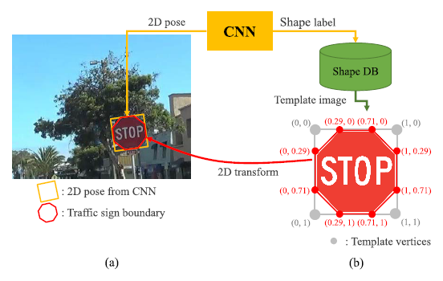

Fig. 1. Boundary estimation using a predicted 2D pose and a shape label.

**EXISTING SYSTEM**

Most of the existing system on traffic sign detection rely on hand-crafted image features to identify target signs.Where color probability maps and multiple thresholding algorithms were used. Also Region-based features like histogram of gradient (HoG), are widely used where accurate decision on traffic sign/non-traffic sign is required. More sophisticated features such as the integral channel features (ICF) or the aggregated channel features (ACF) have also been applied to traffic sign detection systems.

**Disadvantages of the Existing System**

* Used hand-Crafted algorithms for the detection are features designed by hand are known to be weaker than features learned by CNN from massive training data.
* Only the bounding boxes on the traffic signs were detected.
* Accuracy is less.
* Very slow speed of the network.

PROPOSED SYSTEM AND METHODOLOGY USED

In our work,we build the CNN block based on the SSD structure where predictions are directly preformed across multiple feature levels.The main difference of our network with the previous detection networks is what it predicts as output: instead of predicting bounding box coordinates, our network performs *pose estimation*,which can be converted into the boundary estimation of corresponding traffic signs.

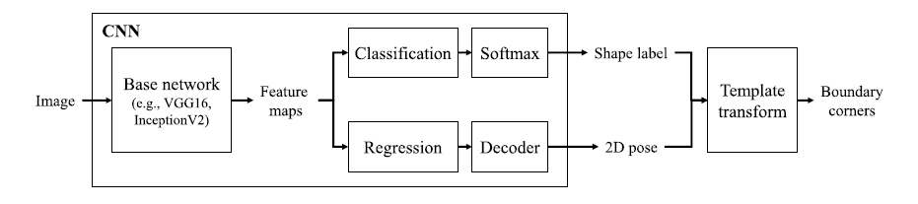

Figure 2: Block Diagram of the Proposed System

In the CNN block, an input image is passed to a base network which extracts feature maps, The shape labels and 2D poses for each default box in a grid are predicted from the feature maps. Then we transform corners of template images that corresponds to the shapelabel using the 2D pose to get the boundary corners for input image.

**Advantages of the Proposed System**

* The proposed system uses convolutional neural network (CNN) to detect the traffic signs.
* The frame detection rate is around 7 frames per second.
* Not only boundary box detection but also the boundary corners is detected for the accurate detection of traffic signs.

TOOLS REQUIREMENT:

**HARDWARE REQUIREMENTS**

The necessary hardware regarding private PC that comprises configuration as specified as follows:-

* Processor: Intel core i3/i5.

SOFTWARE REQUIREMENTS

Matlab MATLAB Version R2017 and above

* Math and computation with Algorithm development.
* Modelling , simulation and prototyping.

**FUTURE DIRECTION:**

For better accuracy or speed of detection, we can adopt the latest architectures for object detection such as feature pyramid network and multi-scale training. Also,the proposed method can be applied not only to traffic sign but also to any other planar objects having standard shapes.

**SOFTWARE REQUIREMENTS**

* MATLAB 7.14 Version R2012

**MATLAB**

The MATLAB high-performance language for technical computing integrates computation, visualization, and programming in an easy-to-use environment where problems and solutions are expressed in familiar mathematical notation.

* Data Exploration ,Acquisition ,Analyzing &Visualization
* Engg drawing and Scientific graphics
* Analyzing of algorithmic designing and development
* Mathematical functions and Computational functions
* Simulating problems prototyping and modeling
* Application development programming using GUI building environment.

Using MATLAB, you can solve technical computing problems faster than with traditional programming languages, such as C, C++, and Fortran.